SMOHIT ARMAN SWAIN
192572092
CSA0504-DBMS
EXPERIMENT 16 :PROCEDURES
Program 1:

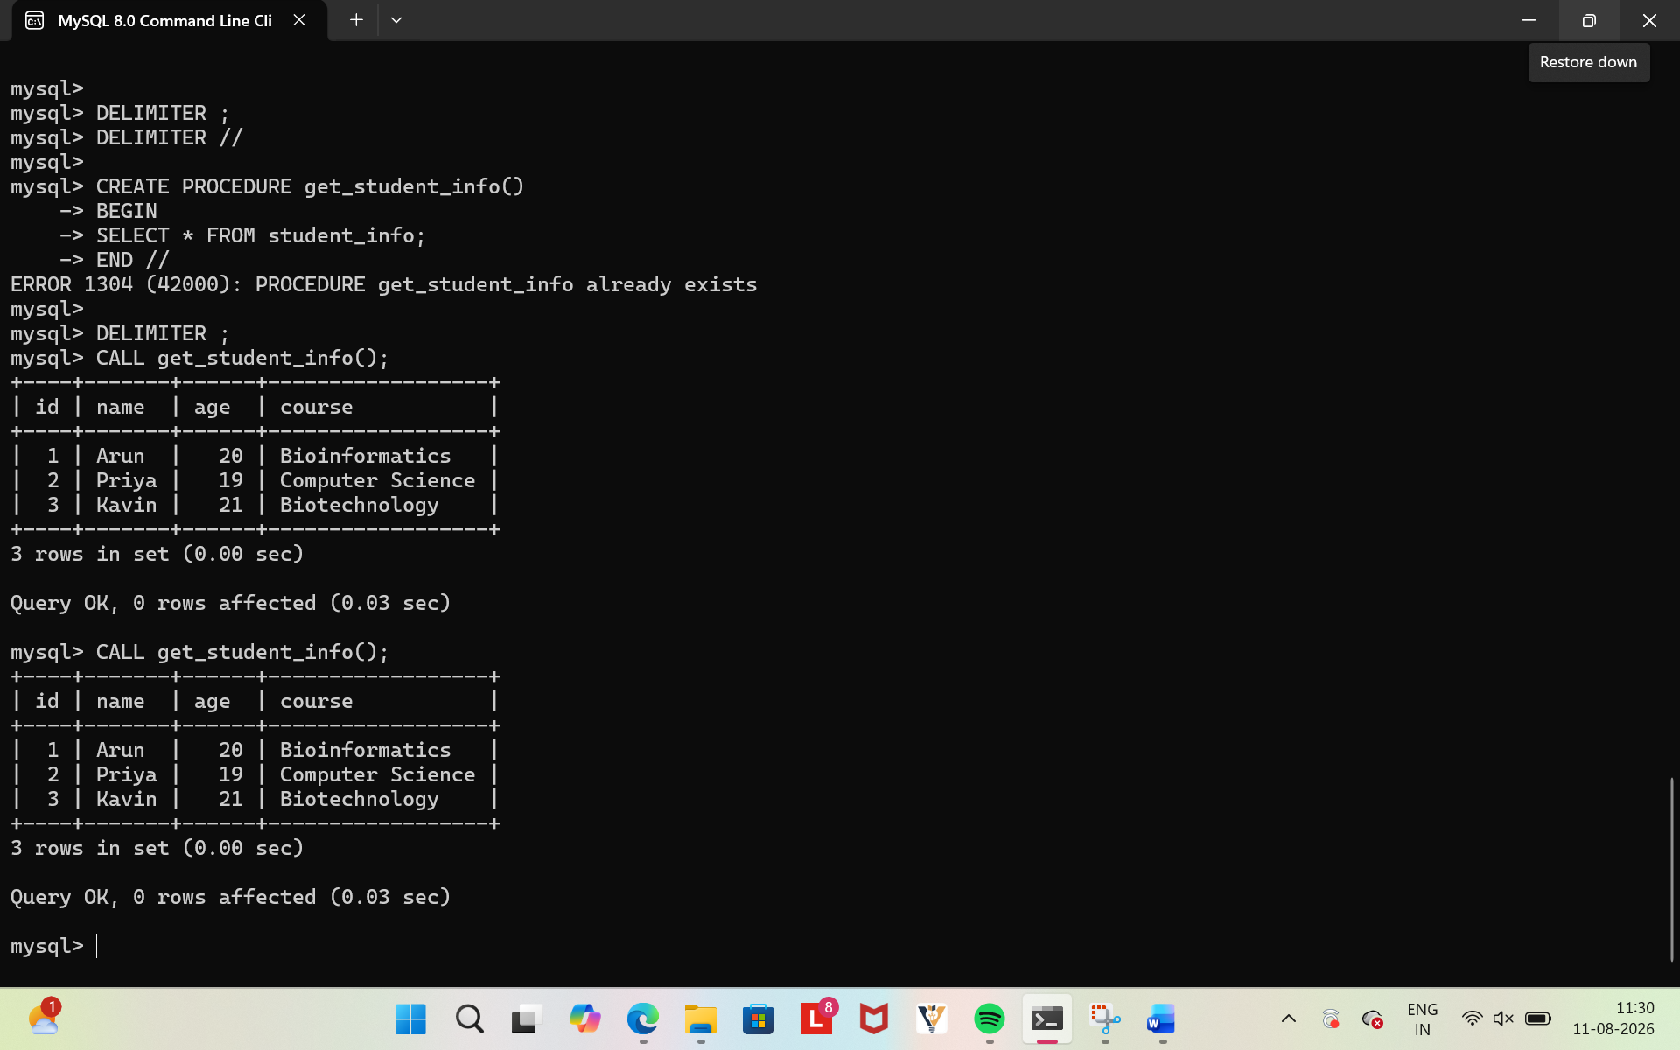
Program 2:

